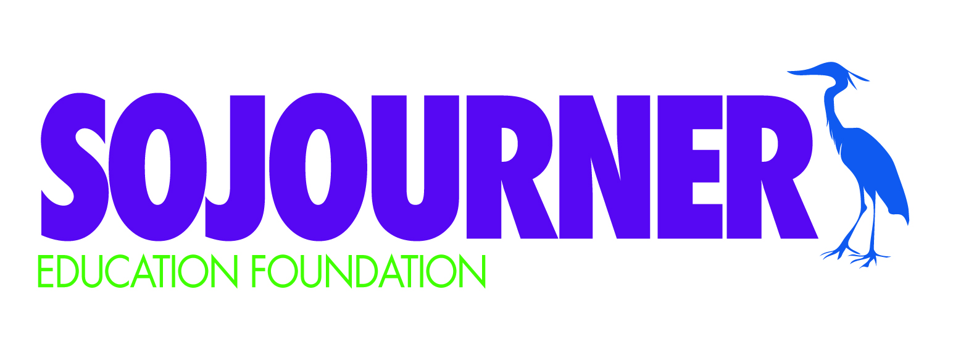

Dear Intermediate Families,
Your child has expressed an interest in participating in the Sojourner Marimba Program, which is managed by the Sojourner Education Foundation. This is a voluntary, after-school activity. Practice is directly after school, from 2:15 – 3:30pm, one day a week, and you can expect for your child to participate in several performances (location varies). Practice will start on October 2nd. Parents are responsible for picking up their own children after practice, providing transportation to performances, and assisting with the transportation of instruments as needed. Each year, the Sojourner Education Foundation estimates the per-student cost for Marimba. This includes staffing/instruction, administrative costs, including insurance and facility use fees, and a Marimba t-shirt. Marimba fees may vary from year to year. For the 2019-20 school year, the per-student marimba fee will be $100 per student.
Before your child can participate, we ask that you do the following:
☑ Review and sign the attached contract, which outlines participation expectations. Signatures from both parent and student are required.
☑ Fill in the Marimba Permission Form.
☑ Submit your payment for the school year.
Please return the contract, permission form and payment by Friday, September 27th.

We hope for every student who wishes to play Marimba to be able to do so! If you need a partial or full scholarship for your child to participate, please indicate your request on the attached Marimba Permission Form. Payment plans can also be arranged — please expect to receive an email from the Sojourner Education Foundation to set up payments.

To pay your Marimba fee:
- Visit www.sojournerschoolcommunity.com and pay using a credit card or Paypal account; or
- Send cash or a check, payable to the Sojourner Education Foundation, to school via your child’s folder. Please put your payment in an envelope labeled Marimba.
If you have any questions about the Marimba program, please contact Shera Sinell at sinells@nclack.k12.or.us. You can also reach out to the Sojourner Education Foundation by sending an email to sef@sojournerschoolcommunity.com.

MARIMBA 2019-2020 PERMISSION FORM

Child’s Name:

Parent/Guardian Name(s):

Address:

Cell Phone Number: Home Phone:

E-mail Address:

Emergency Contact/Phone:

Person(s) Responsible for Picking Child Up From Practice (name/phone):

Days your child would like to attend (circle ALL days that will work):

Monday Wednesday Thursday

T-Shirt Size (circle one):

Youth(S) Youth(M) Youth(L) Adult(S) Adult(M) Adult(L)

I can help transport equipment for special events: Yes No

I will:

Pay in Full*

Pay Installments* (circle one): Two Payments of $50 Four Payments of $25 Monthly Payments $15

Need a Partial Scholarship* – Please indicate how much you can pay $_______________

Need a Full Scholarship

* To make your payment, visit www.sojournerschoolcommunity.com and pay using a credit card or Paypal account, or send cash or a check, payable to the Sojourner Education Foundation, to school via your child’s folder. Please put your payment in an envelope labeled Marimba.

MARIMBA 2019-2020 PARENT/CHILD CONTRACT

I ___________________ (parent/guardian) and ______________________(student) understand that by participating in Marimba, we agree to the following:

- Observing classroom etiquette (not playing instruments unless you are told, respecting others, respecting instruments, no yelling or talking during instruction);

- Regularly showing up to scheduled practices (including one recess and one after school practice per week);

- Participating in performance events (These typically occur in the Spring. If you are unable to make a certain event, it is important that you communicate this to Mrs. Sinell);

- Timely pick up of your child from practice (please include a phone number where we can reach you on the day of practice in the event of a last minute cancellation due to illness/emergency)

Liability Waiver: I understand that participation in the Sojourner Education Foundation Marimba after-school program is voluntary and not part of the Sojourner Elementary School program. I/we understand the Sojourner Education Foundation, Marimba Program and Sojourner School and staff, will not be liable for personal injuries and/or property damage as a result of my child’s participation in this activity.

Parent Signature Date

Child Signature Date

